Wipers Control Function – CGEA1.3

Functional Description

The Wipers Control System provides the customers the option to enable or disable certain wiping/wipers features by using the Message Center Switches and Display. The features consist of:
- Courtesy Wipe After Wash (CWAW)
- Rain Sensing Wipers (RSW)
- Rear Reverse Gear Wipe (RRGW)

Wipers Control Function is displayed only in the Message Center while it is in the appropriate SETUP display. See Message Center X Display Y Button Interface Section, where X and Y are appropriate values in this document for details on when this display is active.

Starting in MY2019 with U625/U611 the Settings are migrating from the cluster to Center stack. This STSS supports displaying settings in the cluster or configuring the cluster settings off if they are displayed in the Center stack.

Interfaces

Interface Context Diagram (I/O Block Diagram)

Wipers Function Context Diagram

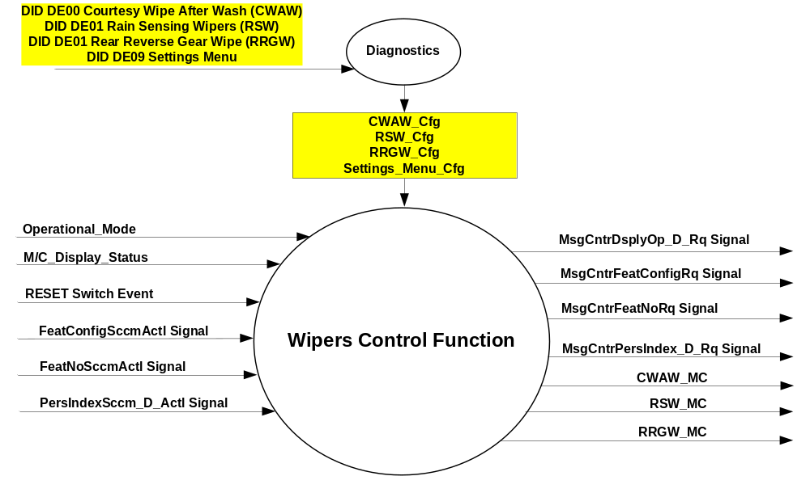

Inputs

IR-REQ-297747/A-INTERNAL
- Operational_Mode
- RESET Switch Event
- CWAW_Cfg
- RSW_Cfg
- RRGW_Cfg
- Settings_Menu_Cfg
- M/C_Display_Status

MUX message on the CAN Bus from SCCM

SIG-REQ-297739/A-FeatConfigSccmActl

Signal Name | Size (bits) | Detail | Units | Res. | Offset | State Encoded | Min | Max
FeatConfigSccmActl | 16 | - | Undefined | 1 | 0 |  | 0  (0x0) | 65535  (0xFFFF)

SIG-REQ-297740/A-FeatNoSccmActl

Signal Name | Size (bits) | Detail | Units | Res. | Offset | State Encoded | Min | Max
FeatNoSccmActl | 16 | - | Number | 1 | 0 |  | 0  (0x0) | 65535  (0xFFFF)

SIG-REQ-297741/A-PersIndexSccm_D_Actl*

Signal Name | Size (bits) | Detail | Units | Res. | Offset | State Encoded | Min | Max
PersIndexSccm_D_Actl* | 3 |  | SED | 1 | 0 |  | 0  (0x0) | 7  (0x7)
 |  | PERS_1 |  |  |  | 0 (0x0)
 |  | PERS_2 |  |  |  | 1 (0x1)
 |  | PERS_3 |  |  |  | 2 (0x2)
 |  | PERS_4 |  |  |  | 3 (0x3)
 |  | Vehicle |  |  |  | 4 (0x4)
 |  | Unused |  |  |  | 5(0x5)
 |  | Unused |  |  |  | 6 (0x6)
 |  | Unused |  |  |  | 7 (0x7)
* Note: This signal is optional. If undefined on a program, then value is always Vehicle (0x4).

REQ-297752/A- Outputs
- CWAW_MC
- RSW_MC
- RRGW_MC

MUX Message on CAN Bus

SIG-REQ-297748/A-MsgCntrDsplyOp_D_Rq

Signal Name | Size (bits) | Detail | Units | Res. | Offset | State Encoded | Min | Max
MsgCntrDsplyOp_D_Rq | 3 |  | SED | 1 | 0 |  | 0  (0x0) | 7  (0x7)
 |  | NULL |  |  |  | 0 (0x0)
 |  | QUERY |  |  |  | 1 (0x1)
 |  | SET |  |  |  | 2 (0x2)
 |  | UPLOAD |  |  |  | 3 (0x3)
 |  | RESTORE |  |  |  | 4 (0x4)
 |  | COPY |  |  |  | 5(0x5)
 |  | Not used |  |  |  | 6 (0x6)
 |  | Not Used |  |  |  | 7 (0x7)
.

SIG-REQ-297744/A-MsgCntrFeatConfigRq

Signal Name | Size (bits) | Detail | Units | Res. | Offset | State Encoded | Min | Max
MsgCntrFeatConfigRq | 16 |  | Undefined | 1 | 0 |  | 0  (0x0) | 65535  (0xFFFF)

SIG-REQ-297745/A-MsgCntrFeatNoRq

Signal Name | Size (bits) | Detail | Units | Res. | Offset | State Encoded | Min | Max
MsgCntrFeatNoRq | 16 |  | Number | 1 | 0 |  | 0  (0x0) | 65535  (0xFFFF)

SIG-REQ-297746/A-MsgCntrPersIndex_D_Rq

Signal Name | Size (bits) | Detail | Units | Res. | Offset | State Encoded | Min | Max
MsgCntrPersIndex_D_Rq | 3 |  | SED | 1 | 0 |  | 0  (0x0) | 7  (0x7)
 |  | PERS_1 |  |  |  | 0 (0x0)
 |  | PERS_2 |  |  |  | 1 (0x1)
 |  | PERS_3 |  |  |  | 2 (0x2)
 |  | PERS_4 |  |  |  | 3 (0x3)
 |  | Vehicle |  |  |  | 4 (0x4)
 |  | Not Used |  |  |  | 5(0x5)
 |  | Not Used |  |  |  | 6 (0x6)
 |  | Not Used |  |  |  | 7 (0x7)

Function/Performance

F-REQ-297749/A-Operational Modes

Mode | Differentiating Vehicle Conditions
Sleep Mode | Wipers Control Function Text Message Disabled
Limited Mode | Wipers Control Function Text Message Disabled
Normal Mode | Wipers Control Function Enabled / Disabled
Crank Mode | Wipers Control Function Text Message Enabled / Disabled

Voltage Levels

Refer to the Cluster Features table located in the Operational Modes and Voltage Range Strategies Section in this SPSS.

Human-Machine Interface

Visual
None

Indicator Graphics / Display FormatFor High End Display (SHMI), refer to “<Program> Cluster Menu Structure.xls” and Program

HMI-REQ-297742/A-STANDARD MENU
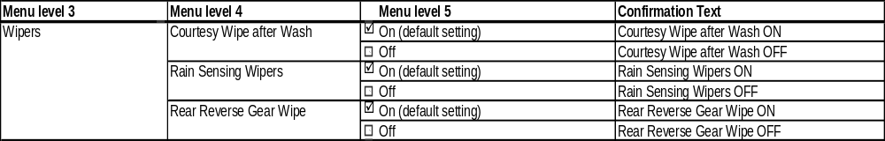

HMI-REQ-297743/B-SIMPLIFIED MENU

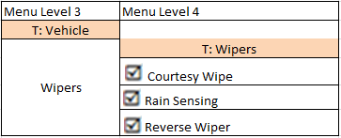

For B Display, refer to Message Center Function description reference "B Display 2x14 Text Message List.xls"– Message ID SUxxx, SUxxx, and SUxxx.

Indicator Color Coordinates

Reference section COLOR & ILLUMINATION REQUIREMENTS (GRAPHICS)

Indicator Characteristics

Refer to Message Center X Display_Y Button Interface Section, where X and Y are appropriate values in this document.

Audio

None

HMI-REQ-297753/A-Switch Control Logic

Consumer access to the Configuration shall be as specified in the message center basic functionality display as specified in Message Center X Display_Y Button Interface Section, where X and Y are appropriate values in this document.

PFM-REQ-297797/A-System Accuracy

Within a 150msec of receiving a message that results in a change of state the cluster will update the display to the proper status.

Operation: Performance and Functional

Subsystem Algorithm Flowchart / State Diagram

F-REQ-297788/A-Wipers Control Diagnostic Configuration Flowcharts

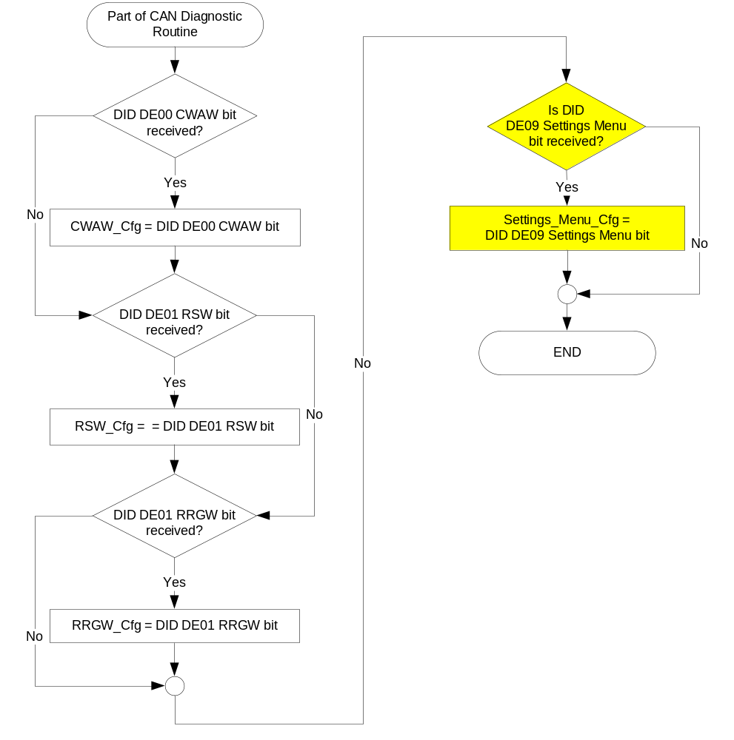

F-REQ-297789/A-Wipers Control output SET request Flowchart

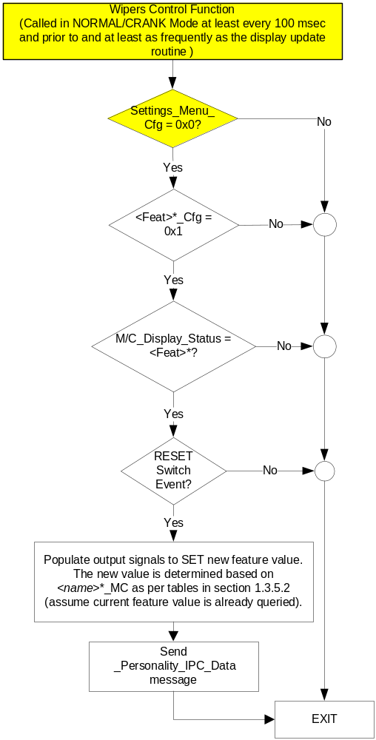

NOTE: In the Remote Start Control Function Flowchart, the definition of "RESET Switch Event" is defined in Message Center X Display_Y Button Interface Section, where X and Y are appropriate values in this document.

* <Feat> and <name> reference CWAW, RSW, and RRGW.

Operation Description (supports algorithm flowchart /state diagram)

F-REQ-297792/A-Courtesy Wipe After Wash (CWAW) State Assignment

FeatNoSccmActl | FeatConfigSccmActl | PersIndexSccm_D_Actl | CWAW_MC |  | Current_PERS ⁽³⁾
0x407 ⁽¹⁾ | 0x0000 (Disable) | 0x0 – 0x4 |  | 0x00 | 0x0 – 0x4
0x407 ⁽¹⁾ | 0x0001 (Enable) | 0x0 – 0x4 |  | 0x01 | 0x0 – 0x4
0x407 ⁽¹⁾ | Other ⁽²⁾ |  |  | 0x04 (Error) |  | Last Known
Missing per Section 1.4.1 ⁽²⁾ |  |  |  |  |  | Last Known
⁽¹⁾ Courtesy Wipe After Wash Feature Number. Reference is Feat Num table in “Vehicle Personalization FS”
⁽²⁾ Message Response is Faulted
⁽³⁾ Equal to the received “PersIndex<--->” signal value . When faulted Keep last known value.

F-REQ-297793/A-Message Center Display and Courtesy Wipe After Wash Request Messages based upon CWAW_MC

CWAW_MC | MC Display  MSG. ID: SUxxx | MsgCntrDsplyOp_D_Rq  Signal | MsgCntrFeatNoRq  Signal | MsgCntrFeatConfigRq  Signal | MsgCntrPersIndex_D_Rq  Signal
0x00 | XXXXXX  ON <OFF> | SET (0x2) | 0x407 | 0x0001 | Current_PERS
0x1 | xxxxxxx  <ON> OFF | SET (0x2) | 0x407 | 0x0000 | Current_PERS
0x04 | xxxxxx  ON OFF | SET (0x2) | 0x407 | 0x0000 | Current_PERS

SHMI Display and Courtesy Wipe After Wash Request Messages based upon CWAW_MC

F-REQ-297784/A-Use for SHI-Display Standard Menu

CWAW_MC | Display Menu | 5-Button Switch Selection Event | MsgCntrDsplyOp_D_Rq  Signal | MsgCntrFeatNoRq  Signal | MsgCntrFeatConfigRq  Signal | MsgCntrPersIndex_D_Rq  Signal
0x00 |  | Up/Down + OK (Select On) | SET (0x2) | 0x407 | 0x0001 | Current_PERS
0x01 |  | Up/Down + OK (Select Off) | SET (0x2) | 0x407 | 0x0000 | Current_PERS
0x4 | 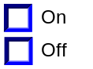 | Up/Down + OK (Select Any) | SET (0x2) | 0x407 | 0x0000 | Current_PERS

F-REQ-297785/A-Use for SHI-Display Simplified Menu

CWAW_MC | Display Menu | 5-Button Switch Selection Event | MsgCntrDsplyOp_D_Rq  Signal | MsgCntrFeatNoRq  Signal | MsgCntrFeatConfigRq  Signal | MsgCntrPersIndex_D_Rq  Signal
0x00 | Courtesy Wipe | OK | SET (0x2) | 0x407 | 0x0001 | Current_PERS
0x01 | ☑ Courtesy Wipe | OK | SET (0x2) | 0x407 | 0x0000 | Current_PERS
0x4 | Courtesy Wipe | OK | SET (0x2) | 0x407 | 0x0000 | Current_PERS

F-REQ-297790/A-Rain Sensing Wipers (RSW) State Assignment

FeatNoSccmActl | FeatConfigSccmActl | PersIndexSccm_D_Actl | RSW_MC |  | Current_PERS ⁽³⁾
0x408 ⁽¹⁾ | 0x0000 (Disable) | 0x0 – 0x4 |  | 0x00 | 0x0 – 0x4
0x408 ⁽¹⁾ | 0x0001 (Enable) | 0x0 – 0x4 |  | 0x01 | 0x0 – 0x4
0x408 ⁽¹⁾ | Other ⁽²⁾ |  |  | 0x04 (Error) |  | Last Known
Missing per Section 1.4.1 ⁽²⁾ |  |  |  |  |  | Last Known
⁽¹⁾ Rain Sensing Wiper Feature Number. Reference is Feat Num table in “Vehicle Personalization FS”
⁽²⁾ Message Response is Faulted
⁽³⁾ Equal to the received “PersIndex<--->” signal value . When faulted Keep last known value.

F-REQ-297791/A-Message Center Display and Rain Sensing Wipers Request Messages based upon RSW_MC

RSW_MC | MC Display  MSG. ID: SUxxx | MsgCntrDsplyOp_D_Rq  Signal | MsgCntrFeatNoRq  Signal | MsgCntrFeatConfigRq  Signal | MsgCntrPersIndex_D_Rq  Signal
0x00 | XXXXXX  ON <OFF> | SET (0x2) | 0x408 | 0x0001 | Current_PERS
0x1 | xxxxxxx  <ON> OFF | SET (0x2) | 0x408 | 0x0000 | Current_PERS
0x04 | xxxxxx  ON OFF | SET (0x2) | 0x408 | 0x0000 | Current_PERS

SHMI Display and Rain Sensing Wipers Request Messages based upon RSW_MC

F-REQ-297786/A-Use for SHI-Display Standard Menu

RSW_MC | Display Menu | 5-Button Switch Selection Event | MsgCntrDsplyOp_D_Rq  Signal | MsgCntrFeatNoRq  Signal | MsgCntrFeatConfigRq  Signal | MsgCntrPersIndex_D_Rq  Signal
0x00 |  | Up/Down + OK (Select On) | SET (0x2) | 0x408 | 0x0001 | Current_PERS
0x01 |  | Up/Down + OK (Select Off) | SET (0x2) | 0x408 | 0x0000 | Current_PERS
0x4 |  | Up/Down + OK (Select Any) | SET (0x2) | 0x408 | 0x0000 | Current_PERS

F-REQ-297787/B-Use for SHI-Display Simplified Menu

RSW_MC | Display Menu | 5-Button Switch Selection Event | MsgCntrDsplyOp_D_Rq  Signal | MsgCntrFeatNoRq  Signal | MsgCntrFeatConfigRq  Signal | MsgCntrPersIndex_D_Rq  Signal
0x00 | Rain Sensing | OK | SET (0x2) | 0x408 | 0x0001 | Current_PERS
0x01 | ☑ Rain Sensing | OK | SET (0x2) | 0x408 | 0x0000 | Current_PERS
0x4 | Rain Sensing | OK | SET (0x2) | 0x408 | 0x0000 | Current_PERS

F-REQ-297794/A-Rear Reverse Gear Wipe (RRGW) State Assignment

FeatNoSccmActl | FeatConfigSccmActl | PersIndexSccm_D_Actl | RRGW_MC |  | Current_PERS ⁽³⁾
0x409 ⁽¹⁾ | 0x0000 (Disable) | 0x0 – 0x4 |  | 0x00 | 0x0 – 0x4
0x409 ⁽¹⁾ | 0x0001 (Enable) | 0x0 – 0x4 |  | 0x01 | 0x0 – 0x4
0x409 ⁽¹⁾ | Other ⁽²⁾ |  |  | 0x04 (Error) |  | Last Known
Missing per Section 1.4.1 ⁽²⁾ |  |  |  |  |  | Last Known
⁽¹⁾ Rear Reverse Gear Wipe Feature Number. Reference is Feat Num table in “Vehicle Personalization FS”
⁽²⁾ Message Response is Faulted
⁽³⁾ Equal to the received “PersIndex<--->” signal value . When faulted Keep last known value.

F-REQ-297795/A-Message Center Display and Rear Reverse Gear Wipe Request Messages based upon RRGW_MC

RRGW_MC | MC Display  MSG. ID: SUxxx | MsgCntrDsplyOp_D_Rq  Signal | MsgCntrFeatNoRq  Signal | MsgCntrFeatConfigRq  Signal | MsgCntrPersIndex_D_Rq  Signal
0x00 | XXXXXX  ON <OFF> | SET (0x2) | 0x409 | 0x0001 | Current_PERS
0x1 | xxxxxxx  <ON> OFF | SET (0x2) | 0x409 | 0x0000 | Current_PERS
0x04 | xxxxxx  ON OFF | SET (0x2) | 0x409 | 0x0000 | Current_PERS

F-REQ-297796/A-SHMI Display and Rear Reverse Gear Wipe Request Messages based upon RRGW_MC Use for SHI-Display Standard Menu

RRGW_MC | Display Menu | 5-Button Switch Selection Event | MsgCntrDsplyOp_D_Rq  Signal | MsgCntrFeatNoRq  Signal | MsgCntrFeatConfigRq  Signal | MsgCntrPersIndex_D_Rq  Signal
0x00 |  | Up/Down + OK (Select On) | SET (0x2) | 0x409 | 0x0001 | Current_PERS
0x01 |  | Up/Down + OK (Select Off) | SET (0x2) | 0x409 | 0x0000 | Current_PERS
0x4 |  | Up/Down + OK (Select Any) | SET (0x2) | 0x409 | 0x0000 | Current_PERS

Rear Reverse Gear Wipe is not a Menu Selection in the SHI_Display Simplified Menu.

FS-REQ-297845/A;1-Function Safety Classification (EMC)
Class B

NVM-REQ-297844/A-Memory Storage
Function Parameters

Parameter Name | Description | Value at  Battery Connect | Value at  Wake-up
- CWAW_MC  - RSW_MC  - RRGW_MC | Output(s) displayed in the M/C | 255 (0xFF) | Do Not Init
Current_PERS | Current Personality Profile | Vehicle (0x4) | Do Not Init
MsgCntrDsplyOp_D_Rq  Signal | Output Signal to indicate Request Type. | NULL (0x0) | Do Not Init
MsgCntrFeatNoRq Signal | Output Signal to indicate Feature Number. | (0x0000) | Do Not Init
MsgCntrFeatConfigRq  Signal | Output Signal to Specify the desired feature Value. | (0x0000) | Do Not Init
MsgCntrPersIndex_D_Rq  Signal | Output Signal to indicate which personality profile is being accessed. | PERS_1 (0x0) | Do Not Init
FeatNoSccmActl | Input signal sent from SCCM to indicate Feature Number. | (0x0000) | Do Not Init
FeatConfigSccmActl | Input signal sent from SCCM to indicate current value of the feature setting for the feature that is being set or queried. | (0x0000) | Do Not Init
PersIndexSccm_D_Actl | Input signal sent from SCCM to indicate which personality profile is being reported. | PERS_1 (0x0) | Do Not Init
CWAW_Cfg  RSW_Cfg  RRGW_CFG | State indicators for feature presence controlled via CAN at EOL at VO plant. Set to disabled at Cluster Supplier Manufacturing Plant | Use Stored Value | Use Stored Value
Settings_Menu_Cfg | Configures cluster to display items in the Settings menu (Set to “cluster” at cluster supplier manufacturer plant) | Use Stored Value | Use Stored Value
M/C_Display_Status | State Indicator to identify which text is currently being displayed on Message Center display. See * | See * | See*
RESET Switch Event | Event that is indicated as per the switch interface for the Message Center. See * | See * | See*
Operational_Mode | 4 state indicator for cluster operational mode | Limited | Limited, Normal or Crank
* Refer to Message Center X Display_Y Button Interface Section, where X and Y are appropriate values in this document.

Reconfigurable Telltale

Not Applicable

Prove Out

Not applicable

Message Center Msg

Refer to Message Center Function description reference "Text Message List - BEF Displays 2x14.xls" file -- Message ID SUxxx, SUxxx, and SUxxx.

Error Handling

Missing Message Strategy

Missing Signal Reference
The signals will be declared missing as per the Diagnostics section of this SPSS.

DTCs States Reference
DTCs states and history will be determined as per the Diagnostics section of this SPSS.

SR-REQ-297799/A-Disable Missing Message DTC Logging
If CWAW_Cfg, RSW_Cfg, and RRGW_Cfg are all Disabled, the cluster shall never log a missing message DTC for this feature.

Configuration Mismatch
None

Diagnostics

Self Test

None

Engineering Test Mode

Reference section “Dealer / Engineering Test Mode (ETM)”

Part II Performance

DTC-REQ-297800/A-Supported Diagnostic Trouble Codes (DTCs)

DTC | Description
C21200 | Lost of Communication with CGEA_HS_SCCM

DCR-REQ-297801/B-DID DE00

Block  Num | Block Description | Byte(s) | Bits | State: Description | "0" | "1" | Default | Comments/  Information
PACKETED BLOCKS
$00 | Option Content (B&A) | * | * | Courtesy Wipe After Wash (CWAW) | Disabled | Enabled | Disabled | This parameter allows the Wiper -> Courtesy Wipe settings menu to be displayed in the cluster. It can be over-ridden by the Settings Menu config. IF THE SETTINGS MENU CFG IS SET TO “CENTER STACK”, THEN DISABLE THIS PARAMETER.
$01 | Option Content (B&A) | * | * | Rain Sensing Wipers (RSW) | Disabled | Enabled | Disabled | This parameter allows the Wiper -> Rain Sensing settings menu to be displayed in the cluster. It can be over-ridden by the Settings Menu config. IF THE SETTINGS MENU CFG IS SET TO “CENTER STACK”, THEN DISABLE THIS PARAMETER.
$01 | Option Content (B&A) | * | * | Rear Reverse Gear Wipe (RRGW) | Disabled | Enabled | Disabled | This parameter allows the Wiper -> Rear Reverse Gear Wipe settings menu to be displayed in the cluster. It can be over-ridden by the Settings Menu config.  ***Enable if Feature Present***  IF THE SETTINGS MENU CFG IS SET TO “CENTER STACK”, THEN DISABLE THIS PARAMETER.
$09 | Option Content (B&A) | * | * | Settings Menu | Cluster | Center Stack | Cluster | This parameter allows the Settings menu to be displayed in the cluster when 0x0. When 0x1, the expectation is that settings are displayed in the Centerstack. For this feature (when 0x1), the cluster will remove almost all items from settings menu. (Cluster display choices remain). Note this is a global config, each feature still has its own config for presence on vehicle.
*Byte and bit location to be identified in Part II Specification for this cluster

Reference Specification

None

Revision History
SPSS Module Revision History

Revision Level | Name | Change Description | Date
1.0 | V. Patel | Updated for CGEA 1.3 based on CGEA STSS v1.0  Section 1.2.2 – Removed table referencing the HS-CAN message that contains the input signal.  Section 1.2.3 – Removed table referencing the HS-CAN message that contains the output signal.  Section 1.2 – Deleted “Position” column from the input and output signal tables.  Section 1.4 – Rewritten. Deleted references of specific missing message flags and timer.  Section 1.5.3 – Deleted DTC logging criteria from the table. | 4/22/2010
1.1 | S. Watkins | Since vehicles are now set to Personalization setting “Vehicle (0x4)”, the use of the PersIndex…_D_Actl signals is optional. On CD4, the signal PersIndexHvac_D_Actl is undefined. Therefore, I made a note below Table 1.2 that this signal is optional, and to use 0x4 always if the signal is undefined on a program. Also, there was a typo in Table 1.1. Changed “FeatNoSccm_No_Actl” to “FeatNoSccmActl”. | 1/20/2011
2.0 | T. Cwik | Updates to incorporate the changes needed for the Menu Simplification effort  Section 1.3.3.2 – Added Simplified Menu Layout  Section 1.3.5.2 –  – Corrected MsgCntrFeatNoRq Signal to 0x407 in Table 1.9  – Added Simplified Menu Matrix to Table 1.9  – Corrected MsgCntrFeatNoRq Signal to 0x408 in Table 1.12  – Added Simplified Menu Matrix to Table 1.12  – Corrected MsgCntrFeatNoRq Signal to 0x409 in Table 1.15  – Added Simplified Menu Note below Table 1.15 | 9/12/2012
3.0 | S. Watkins | Starting in MY2019 with U625/U611 the Settings are migrating from the cluster to Centerstack. This STSS update is to support this effort. A configuration is added to ensure backward compatiblity.  Changes shown in yellow:  - Section 1.1 – Updated description to mention Center Stack  - Section 1.2.1, Figure 1 – Added DE09 Settings Menu  - Section 1.2.2 – Added Settings_Menu_Cfg  - Section 1.3.1 – Added “Enabled” to Crank mode (defect fix unrelated to other changes)  - Section 1.3.5.1, Figure 2 – Added DE09 Settings Menu  - Section 1.3.5.1, Figure 4 – Added decision box for Settings_Menu_Cfg and also added “Crank” to first box (defect fix unrelated to other changes).  - Section 1.3.5.4 – Added Settings_Menu_Cfg  - Section 1.5.3 – Added Settings Menu to DE09 | 1/17/2017
3.1 | A. Mathai | VSEM RM export | 2/21/2018
3.2 | H. Sharma | Simplified Menu Update requested by Brianne Goodwin and approved in DI Change Control on 03/01/2018.  Section 1.3.3.2.2 HMI-REQ-297743/B-SIMPLIFIED MENU is updated and Reverse Wiper is added to Wipers Menu on Menu Level 4.  Reason for Proposed Change: When owner is in reverse and using the front wipers, the vehicle will automatically engage the rear wipers as well if Reverse Wiper is enabled in menu. | 3/14/2018
3.3 | H. Sharma | Watermark “Draft” Removed | 3/23/2018

